**Protocol and Verbal Instructions for Online Sessions for EXPERIMENTER**

**ROOM PREP (Just Once):**

<

* Connect Nexus MK10 via USB
  + Charge Battery
* Connect Sensors to Nexus MK10:
  + Ground
  + Channel A/B: [1] EXG (EEG) / [2] EXG (ECG)
  + Channel E: SC/GSR
  + Channel F: Temperature
* Create Participants in Nexus BioTrace+
* Create Copies of the Raw Code for each Participant
* Close Window Blinds
* Print out Consent Forms
  + Consent Form – Sensor Data
  + Consent Form – Interview Recording

>

**ROOM PREP (Before every Session):**

<

* Open Fish Tank Movie
* Open Fixation Cross
* Open Hexagon Document
* Prepare Fresh Electrodes on:
  + Ground 🡪 Left Collar Bone
  + 2x Channel A/B: EXG (EEG)
  + 2x Channel C/D: EXG (ECG)
  + 2x Channel E: SC/GSR
* Turn on Audio recorder
* Open PowerPoint on Desktop
* Hang Up “Do not Disturb: Session under Way” Warning on the Lab Door

>

**DATA PREP:**

<

* Open fresh JHotDraw Project in IntelliJ IDEA (Version 2022.2 → newer versions will not work because they do not support JDK 6 anymore!)
  + Open Folder “JHotDraw6”
  + Copy Fresh Working Code and rename it by adding Participant ID
  + Make sure IntelliJ runs in light mode
* Start Interruption App
  + Enter Participant ID
* Start Interruption App in Demo Mode
* Change PARTICIPANT_ID in C:\Users\experiment\Documents\Code\Personal-Analytics-Simple-Tracker\ActivityTracker\main.js
* Change PARTICIPANT_NAME in C:\Users\experiment\Documents\Code\Tobii SDK Project\main.py
* Change PARTICIPANT_NAME in C:\Users\experiment\Documents\Code\Tobii SDK Project\main_baseline.py
* Select Participant in BioTrace+ Software
  + Open EEG 1 band Multimodal Screen from the Signal Library

>

**CONDUCTING GUIDELINE:**

<EXPERIMENTER guides the session in a calm/friendly but efficient manner. When deviating from the protocol (e.g., jokes), the experimenter should try to swiftly steer back to the protocol>

<Questions from the participants are allowed during the pre and post phase. In the main phase, participants should only ask questions in case something malfunctions and needs experimenter intervention.>

**EXPERIMENT START:**

<EXPERIMENTER will allow participant to enter from the waiting room, checks them off the participant list, when the participant enters, says:>

***EXPERIMENTER 1:*** *“Welcome to this experiment. We will first start with an explanation of the tasks you will do in the next 60 minutes. Afterwards we will ask you a couple questions for the pre interview. After that we will show you all the necessary sensors, place them on you and start the recording. We will then record some baseline measurements. Afterwards we will do a demo run of the simulated interruption. Finally, we will start the recording and leave you for the next 60 minutes to complete the tasks. The preparation will take 30 minutes, the experiment will take 60 minutes and the post interview will take 15 minutes.*

***EXPERIMENTER:*** *“We will now give you the instructions for this experiment. “*

<Experimenter presents power point in full screen mode and starts reading out the instructions.>

***EXPERIMENTER:*** *“The PowerPoint presentation will remain open in case you need the information during the session. In case you close the PowerPoint app the presentation is placed on the desktop. “*

**CONSENT COLLECTION:**

<Experimenter hands out consent form to participant>

<Experimenter asks participant to turn his smartphone silent>

**PRE INTERVIEW:**

<Experimenter starts recording pre interview>

<Experimenter asks questions from the post interview document: “INTERVIEW PRE.pdf”>

**NEXUS-10 PREP:**

< Show and briefly explain each Sensor before placing it on the participant.

1. Place 7 Electrodes and 1-2 Sensors:
   1. EEG:
      1. Forehead left side (Fp1) (+ Measurement)
      2. Mastoid behind left ear (- Reference)
   2. ECG (Vertical Lead II):
      1. Lower left rib cage (+ Measurement): Place the red electrode on the lower left rib cage.
      2. Right Collarbone (- Reference): Place the black electrode on the distal end of the right collarbone. With this electrode placement, the polarity of the R peak is correct.
   3. Ground: Left Collarbone: Place the ground electrode on the distal end of the left collarbone.
   4. Skin Conductance:
      1. (I) Left Wrist
      2. (II) Left Wrist below
   5. Temperature:
      1. Right Wrist
2. Press Record
3. Check if Sensors work:
   1. EEG: BioTrace+ → Signal Library → EEG → EEG 1 Band
      1. Check proper grounding: No 50Hz Peak
      2. Compare with reference (see Figure 1)
   2. ECG/Respiration: BioTrace+ → Signal Library → EEG → ECG
      1. Compare with reference (see Figure 2)
   3. File → Load a Screen → My Screens → „Experiment Monitor ALL Sensors.bcscr“
   4. SC & Temp.: Compare with reference (see Figure 3)
4. Cancel Recording after Successful Check

>

**RECORD BASELINE:**

<

1. Open Fish Tank Movie
2. Instruct Participant to relax and watch the video
3. Record 2 Minutes of Base Line Data

>

**DEMO INTERRUPTION:**

<

* Experimenter guides Participant through Demo Interruption
  + Presenting Instructions in the “Task Explanation.pptx” PowerPoint Presentation
* Close Demo and Open Interruption App in Full Screen Mode

>

**START RECORDING:**

<

* EXPERIMENTER prepares timer
* Start Nexus Recording
* Start Activity Recording in IntelliJ
* Hide Tracking Software Windows (using “Window Hide Tool”)

>

***EXPERIMENTER:*** *“We will now leave the room. We will monitor your actions behind the mirror, but you will be left uninterrupted for the next 60 Minutes. Please press START on the Tablet now.“*

<EXPERIMENTER starts timer>

<EXPERIMENTER walks out and goes into the control room>

<Once 45 minutes have passed, the EXPERIMENTER walks in. If the participant is currently dealing with an interruption on the tablet, the EXPERIMENTER waits for the participant to complete it before walking in. >

***EXPERIMENTER****: “You may now move on to task 3, if have not done so already. You can return to the other tasks after finishing task 3, if those are still unfinished.”*

<Once 60 minutes have passed, the EXPERIMENTER walks in. If the participant is currently dealing with an interruption on the tablet, the EXPERIMENTER waits for the participant to complete it before walking in. >

***EXPERIMENTER****: “The main phase is now completed. You can stop working on the task. We will now stop the sensor recording and take off the sensors. Afterwards we will ask you a couple of questions for a short post interview.”*

<EXPERIMENTER stops recording and takes off sensors>

<

1. Close Interruption App
2. Stop BioTrace+ Recording
3. Stop Activity Tacking in IntelliJ
4. Take Off Sensors
5. Charge Nexus Battery

>

**POST INTERVIEW:**

<Experimenter starts recording post interview>

<Experimenter asks questions from the post interview document: “INTERVIEW POST.pdf”>

***EXPERIMENTER:*** *“The experiment is now completed. You may now sign the attendance list after which you will receive your compensation in cash. Thank you for your participation. ”*

**REFERENCE MEASUREMENTS:**

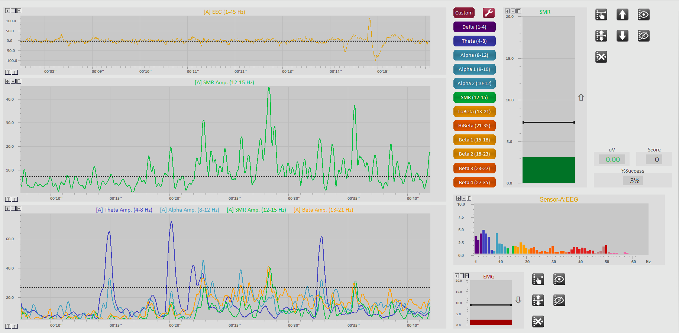

Figure 1 Reference for EEG

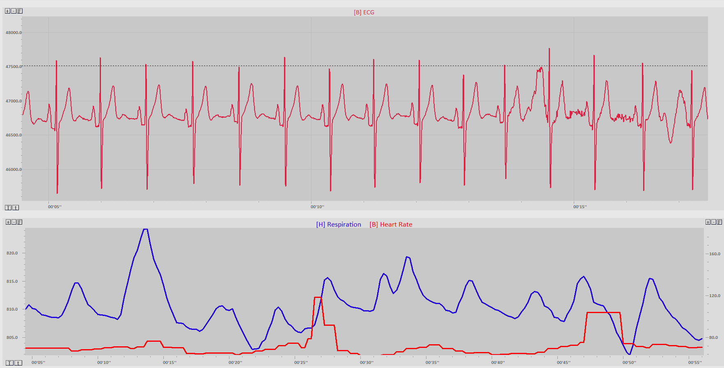

Figure 2 Reference for ECG and Respiration

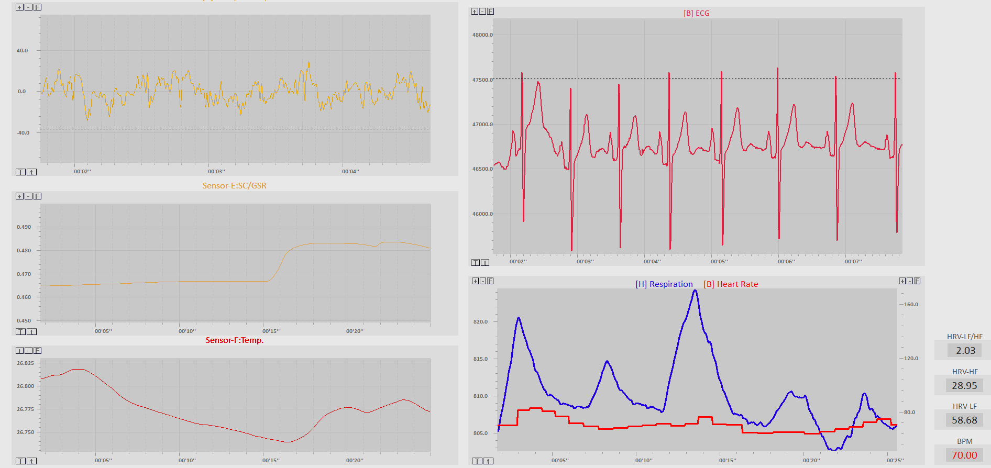

Figure 3 Reference for Skin Conductance & Temperature